|  |  |  |
| --- | --- | --- |
|  |  |  |

**ARAB ACADEMY FOR SCIENCE, TECHNOLOGY AND MARITIME TRANSPORT**

***College of Computing and Information Technology***

Department of

**Computer Science and Software Engineering**

CCIT Graduation Project

**Gamified E-learning System for Kids**

By:

* *Kirolos Khamis 17100652*
* *Boula Nessim 17100676*
* *Ibrahim Samy 17100648*
* *Hesham Mousa 17101452*
* *Mohamed Ali 17100677*
* *Ayten Elsayed 17101874*

*Supervised by*

***Dr. Nada Hany***

*Date of examination*

*14/7/2021*

ABSTRACT

Our graduation project is mainly about gamified E-learning for kids to fulfill their thirst for knowledge and offers online content that can be delivered for children anywhere, and anytime. Also, teachers can create content and, Parents can supervise their children's performance.

Students can keep track of their courses, check availability and obtain knowledge through E-learning systems rather than the traditional teaching and learning. Parents can monitor all children's types of courses, services, and academic performance. Parents can access all system functionalities without any restrictions on their children. Teachers can only manage the content of the course and upload all of the resources and materials.

Our website contains a classroom that will help teachers to upload materials for students and resources that enable students to access it at any time which is very important to enhance the performance of the students on their study.

يتمحور مشروع التخرج الخاص بنا بشكل أساسي حول التعليم الإلكتروني المحبب للأطفال لإشباع تعطشهم للمعرفة ويقدم محتوى عبر الإنترنت يمكن تسليمه للأطفال في أي مكان وفي أي وقت. أيضًا ، يمكن للمدرسين إنشاء محتويات دراسيه ويمكن للآباء مراقبة أطفالهم.

يتعين على الطلاب متابعة المواد الدراسيه وقاعات المواد الدراسيه والتحقق من توفرها والحصول على المعرفة من خلال أنظمة التعلم الإلكتروني بدلاً من التدريس والتعلم يدويًا. على أولياء الأمور مراقبة جميع أنواع خدمات المواد للأطفال وأدائهم الأكاديمي. يمكن للوالدين الوصول إلى جميع وظائف النظام دون أي قيود على أطفالهم. يمكن للمدرسين فقط إدارة محتويات المواد الدراسيه وتحميل جميع الموارد والمواد الدراسيه.

يحتوي موقعنا على فصل دراسي يساعد المعلم في تحميل المواد الدراسيه للطلاب والموارد التي تمكن الطالب من الوصول إليها في أي وقت وهو أمر مهم للغاية لتحسين أداء الطالب في دراستهم.

Acknowledgment

We would like to express our deep gratitude and special thanks to Dr. Nada Hany for her continuous support, patient guidance, enthusiastic encouragement, and useful reviews of this work, in addition to giving us productive recommendations on this project.

Without her advice and assistance in keeping our progress consistent, helping us to understand all challenges and the market requirements throughout the development period of this project, the work would not have been achievable.

Table of Contents

List of figures 3

1 Introduction 5

1.1 purpose 5

1.2 Project Scope 5

1.3 product Features 5

1.3.1 Feature for teachers 6

1.3.2 Feature for students 6

1.3.3 Feature for parents 6

1.4 Project objective 6

2 BACKGROUND AND LITERATURE REVIEW 8

2.1 THEORETICAL BACKGROUND 8

2.1.1 What is Gamification? 8

2.1.2 Gamification Elements for our learning System 8

2.1.3 Mapping Between the Big 5 and Hexad 10

2.1.4 Mapping Between Hexad and Game Elements 11

2.1.5 Gamification User Types Hexad framework 11

2.2 IMPLEMENTATION TECHNOLOGY 12

2.2.1 User Interface 12

2.2.2 Software Interface 12

2.2.3 Hardware Interface 13

2.2.4 Used Technologies 13

3 Requirements Gathering 14

3.1 user classes and characteristics 14

3.2 Functional Requirement 14

3.2.1 Functional requirement of teachers 14

3.2.2 Functional requirement of Student 15

3.2.3 Functional requirement of parents 17

3.3 Nonfunctional Requirement 18

4 SOFTWARE DIAGRAMS 20

4.1 Structural Diagrams 20

4.1.1 Entity Relational Diagram (ERD) 20

4.1.2 Class Diagram 21

4.1.3 Deployment diagram 22

4.2 Behavioral Diagrams 23

4.2.1 Use Case 23

4.2.2 State Chart 26

4.2.3 Activity Diagram 28

4.2.4 Sequence Diagram 47

5 Product Implementation 62

6 FUTURE WORK AND CONCLUSION 63

6.1 Future work: 63

6.2 Conclusion 63

List of figures

Figure 4.1 1 ERD 20

Figure 4.1 2 Class Diagram 21

Figure 4.1 3 Deployment Diagram 22

4.2 1(use case) 23

4.2 2 (use case cont(1)) 24

4.2 3(use cse cont(2)) 25

4.2 4(state chart) 26

4.2 5(state chart cont(1)) 27

4.2 6(state chart cont(2)) 27

4.2 7(Activity diagram) 28

4.2 8(Activity diagram cont(1)) 29

4.2 9(Actvity diagram cont(2)) 30

4.2 10 (Activity diagram cont(3)) 31

4.2 11(Activity diagram cont(4)) 32

4.2 12(Activity diagram cont(5)) 33

4.2 13(Activity diagram cont(6)) 34

4.2 14(Activity Diagram cont(7)) 35

4.2 15(Activity Diagram cont(8)) 36

4.2 16(Activity diagram cont(9)) 37

4.2 17(Activity diagram cont(10)) 38

4.2 18(Activity Diagram cont(11)) 39

4.2 19(Activity Diagram cont(12)) 40

4.2 20(Activity Diagram cont(13)) 41

4.2 21(Activity Diagram cont(14)) 42

4.2 22(Activity Diagram cont(15)) 43

4.2 23(Activity diagram Cont(16)) 44

4.2 24(Activity Diagram Cont(17)) 45

4.2 25(Activity Diagram cont(18)) 46

4.2 26(Sequence Diagram) 47

4.2 27(Sequence Diagram cont(1)) 48

4.2 28(Sequence Diagram cont(2)) 49

4.2 29(Sequence Diagram cont(3)) 50

4.2 30(sequence Diagram cont(4)) 51

4.2 31(Sequence diagram cont(5)) 52

4.2 32(Sequence Diagram cont(6)) 53

4.2 33(Sequence Diagram cont(7)) 54

4.2 34(Sequence Diagram cont(8)) 55

4.2 35(Sequence diagram cont(9)) 56

4.2 36(Sequence Diagram cont(10)) 57

4.2 37(Sequence Diagram cont(11)) 58

4.2 38(Squence Diagram cont(12)) 59

Chapter One

# Introduction

## purpose

Nowadays the parents are too busy that they cannot observe their kids and their activities a properly and frequently. In addition, many students face some problems in understanding important concepts accurately in the class. Besides, there are lots of students who are interested to learn however they face a huge problem that they cannot get enough resources or accessibility. So, Our E-learning System for kids is going to be implemented for them. E-learning will automate the major operations of the learning. Students can keep track of their course and hall courses and check availability. Parents can monitor all children's types of courses, services, and academic performance. Parents can access all system functionalities without any constraints on their children. Students can access all system functionalities with limited restrictions. Teachers can only manage the contents of the course and upload all of the resources and materials.

## Project Scope

Learning System for kids is education via the Internet, network, or standalone computer. Learning System for kids is the network-enabled convey of skills and knowledge. It may help to study perfectly in a very short time and will help students to know the management of past year perfectly. It also helps them through gamification that can be defined as a set of activities and processes to solve problems by using or applying the characteristics of game elements.

* Ability to
* Engage teachers and students in the classroom.
* Help parents to follow their children's activities and grades.
* Use tools like gamification to facilitate learning for kids.
* Manage students to view grades and courses uploaded of their exams easily.
* Give teachers access to update their courses and result on the classroom or website.
* Have chatbot access to answer a specific question.

## product Features

### Feature for teachers

* Register on the system
* Login into their account after registration in the system?
* Create classrooms for courses.
* Assign classwork for students.
* Review the interaction of students to the website.
* Set result of students.
* Chatbot to answer specific questions to the students, parents, if there is no answer all the actors can interact with each other.

### Feature for students

* Creating free accounts.
* The system is responsible for choosing the Gamification method for students by surveying to ask about their personalities type.
* Login to his account
* Have access to upload their classwork.
* Showing the submission status of assignments.
* View their grades.
* View the schedule.
* Review the details including (Rank, Grades, Registered courses, and Feedback) of students.
* Chatbot to answer specific questions to the students.
* Notifications of deadlines for students.

### Feature for parents

* Register free accounts.
* Login into their account after registration in the system?
* Review the details including (Rank, Grades, Registered courses, and Feedback) of their children.
* Interact with teachers and the system.

## Project objective

It is a statement that defines the specific objective that the project aims to achieve. The main objective of our project is to create Learning System for kids that refer to using electronic applications and processes to learn. includes all forms of electronically supported learning and teaching. The project objective also includes parents that are following their students' grades and teachers to interact with their students, and some gamification to help them to have easy learning.

Chapter Two

# BACKGROUND AND LITERATURE REVIEW

## THEORETICAL BACKGROUND

### ****What is Gamification?****

**Gamification** is the application of game-design elements and game principles in non-game contexts. It can also be defined as a set of activities and processes to solve problems by using or applying the characteristics of game elements.

Games and game-like elements have been used to Educate, Entertain and Engage for thousands of years. Some classic game elements are Points, Badges, and Leaderboards.

* **Points** are used as visual identifiers of progress in sports, reward cards, and video games.
* **Badges** display achievement, whether from service in the military or a gold star on a school report card.
* **Leaderboards** are used across sports, sales teams, and in general life to present competitive placement.

#### Big Five Personality Traits

The most used model of personality through academic psychology. Those five personality traits are abbreviated as OCEAN, which are:

* **Openness**: known as curious and open to new ideas.
* **Conscientiousness**: known as organized and systematic.
* **Extraversion**: known as being outgoing and enjoy social situations.
* **Agreeableness**: known as being tolerant and trusting.
* **Neuroticism**: known as being anxious and moody.

### Gamification Elements for our learning System

#### General

* On-boarding / Tutorials: No one uses manuals anymore! Help people get used to your system with a nice tutorial or a gentle introduction on how everything works.
* Fixed Reward Schedule: Reward people based on defined actions and events. First activity, level up, progression. Useful during on-boarding and to celebrate milestone events.
* Time Pressure: Reducing the time people have to do things can focus them on the problem. It can also lead to different decisions.
* Progress / Feedback: Progress and feedback come in many forms and have many mechanics available. All User Types need some sort of measure of progress or feedback, but some types work better than others.

#### Personalized

* **Openness**: Access (**Philanthropists**), Branching Choices **(Free Spirit)**
* **Conscientiousness**: Access (**Philanthropists**), Certificates **(Achiever)**, Badges/Leaderboards **(Player)**
* **Extraversion**: Access (**Philanthropists**), Teams **(Socializer),** Branching Choices **(Free Spirit)**
* **Agreeableness**: Access (**Philanthropists**), Social Status **(Socializer)**
* **Neuroticism**: Branching Choices **(Free Spirit),** Anonymity **(Disruptor)**

### Mapping Between the Big 5 and Hexad

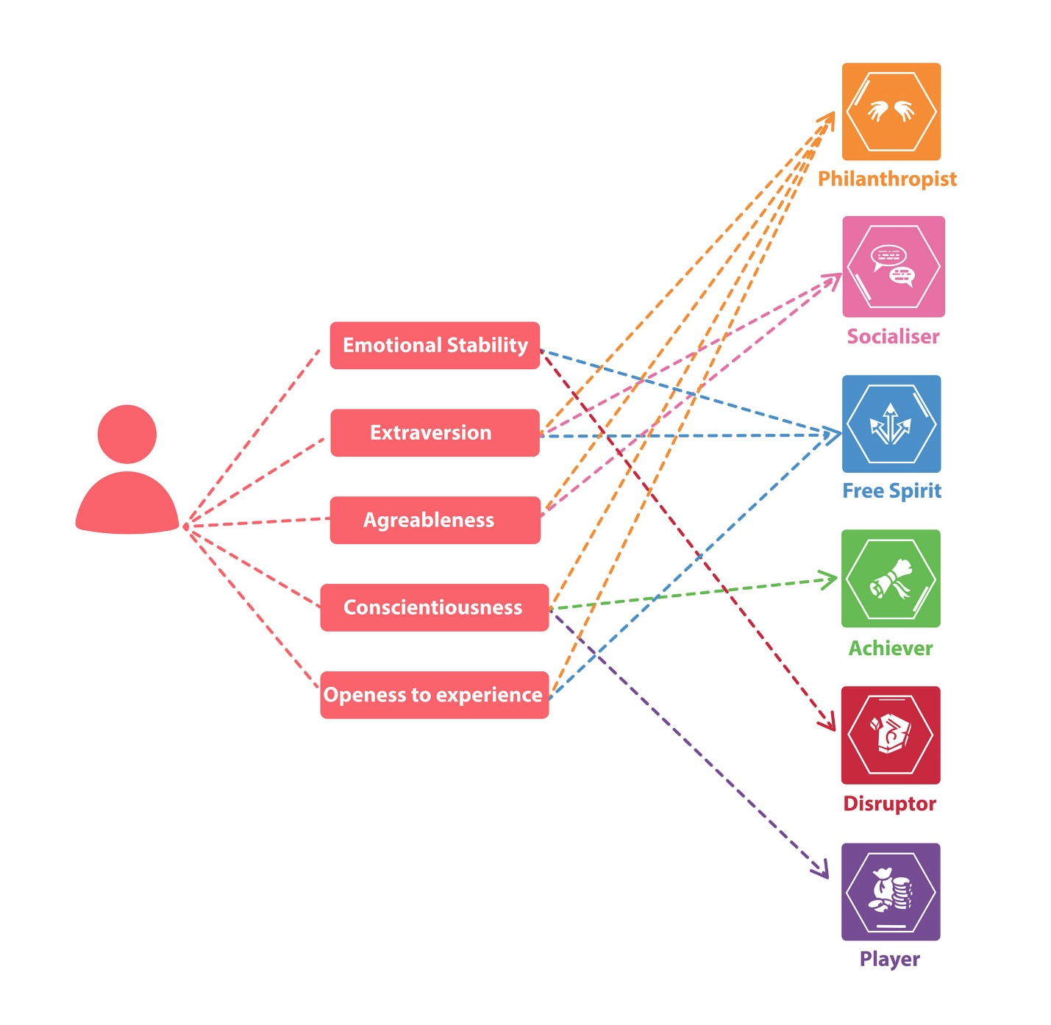

### Mapping Between Hexad and Game Elements

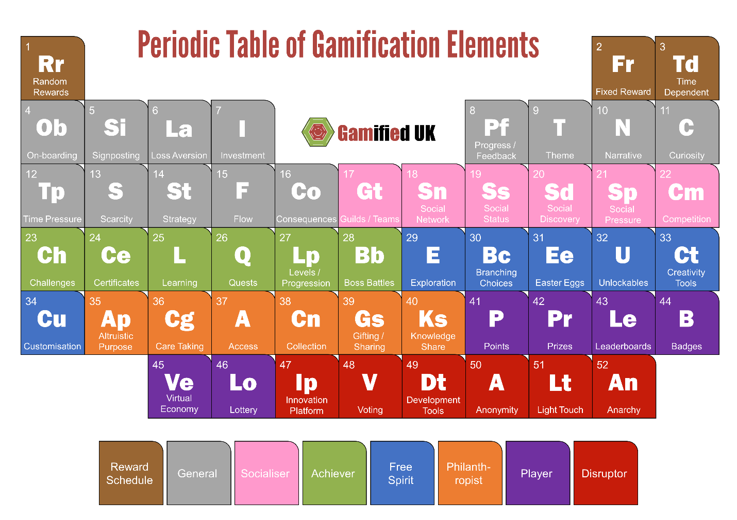

### Gamification User Types Hexad framework

classifies users as follows:

* **Philanthropists** who are altruistic and willing to give without expecting a reward.
* **Socializers** want to interact with others and create social connections.
* **Achievers** seek to progress within a system by completing tasks or prove themselves by tackling difficult challenges.
* **Free Spirits** are motivated by the freedom to express themselves. They like to create and explore within a system.
* **Players** will do whatever to earn a reward within a system, independently of the type of activity.
* **Disruptors** tend to disrupt the system either directly or through others to force negative or positive changes.

## IMPLEMENTATION TECHNOLOGY

### User Interface

Since this is a Web-based application so it should provide a good user-friendly interface. Also, it should be easy to navigate without any obstructions. A decent and pleasant appearance with ease of navigation should help users.

UI-1: Main page interface which includes brief description video about the website, and it also includes control buttons to sign in.

UI-2: Sign-in form using a sign-in form interface.

UI-3: in case you do not have an account, register using the registration form interface which is used for registration for the first time with determining the registerer type.

Teachers UI

UI-4: creating a new term.

UI-5: Creating a new Classroom by clicking the button of creating classroom.

UI-6: Can sign in to a Classroom using the classroom code.

After being in the specified classroom,

UI-7: can upload materials, create posts, assign new assessments, set grades, set deadlines, log out button.

UI-8: Interacting with students by having a shared chat.

UI-9: teachers can give feedback or report about students.

Parents UI

UI-10: Can view their children only.

After Being in the specified classroom,

UI-11: View grades of their own child “children”, view rank, teachers report, logout button

Students UI

UI-12: can view their term courses and insert the specified code for each course.

UI-13: can view materials, grades, assessments, deadlines, upload assignments, and exams.

UI-14: Interact with teachers using the chatbot.

UI-14:

### Software Interface

The communication between client and server is asynchronous. This will help to handle a large number of users simultaneously. The portal should support all major web browsers that will make it convenient for the user to access our system with ease. The back- end i.e. the database services will be used to a great extent and hence it will be quite efficiently designed.

SI-1: developer responsibilities which are, allow removing content and edit pages and user profiles.

SI-2: server interface which allows developers to control both database and websites overall, it may help to improve database connection and availability of the website.

### Hardware Interface

The hardware requirement at the user end is simple and the Portal will be available on the hardware that can run a basic simple browser, provided the hardware should be competent enough during peak times for the web servers.

HI-:1 Screen, PCS interfaces

### Used Technologies

Web Application

Front-end: CSS3, HTML5, Bootstrap 4,5, jQuery "Libraries", JavaScript, Survey.io, Vue Js

Back-end: php "Laravel php framework", MySQL database "phpMyAdmin".

framework: - Vue Js, React Js.

Application Interface:

Since this is a Web-based application so it should work on major browsers like Internet Explorer, Mozilla Firefox, Google Chrome, Opera, etc.

Safety and Security Constraints:

Since the application is designed for the authenticated users only should be allowed to access the data. Also, any anonymous people should not be able to access, edit, modify or even see these data.

Chapter Three

# Requirements Gathering

## user classes and characteristics

**Students:** They are the people who study in the school.

**Parent:** They are the guardians of the students.

**Teacher:** They are persons who teach a different subject

## Functional Requirement

### Functional requirement of teachers

**1) Teachers can register on the system**

* Sign up for a new account
* Enter full name
* Enter password
* Enter email
* Enter gender
* Verification
* If any field of the registration is missing students are not able to register a new account.
* After successful register, students can choose their educational level and the courses they want to learn

**2) Teachers can log in to their account after registration in the system**

* Enter username
* Enter password
* Login

**3) Create classrooms for courses**

* After login account
* Press create classroom
* Enter a name for classrooms
* The system gives code to teachers
* Teachers can send code to students or share it

**4)Assign classwork for students**

* Teacher press to assign new assignment after login account
* Teachers set the deadline for each assignment
* If students assign after deadlines, it will be missed
* If students uploaded the assignments after deadlines, it will be late
* If students assign before deadlines they can turn in his assignment
* After students turn in assignments, teachers can make marks for each student

**5) Upload materials of course for students**

* After login teachers can press upload new material
* Upload can be files such as word documents or videos
* After teachers finish upload students can download files from the website to their laptop or computer

**6) Teachers can review the interaction of students on the website**.

* Teachers can know the number of the students who interact in the classroom which is:
* Who uploads the assignment.
* Who download or view the videos or word documents

**7) set the result of students**

* Teachers can set results after the deadline of each assignment and after exams in classrooms
* Students can view their results on the website

**8) Chatbot to answer specific questions to the students, parents, if there is no answer all the actors can interact with each other**

* After students or parents login
* They can see a chatbot side of the website
* Students or parents can ask questions throw chatbot
* The system will respond automatically if there are unknown questions it will pass to teachers of this course
* Teachers respond as soon as possible

### Functional requirement of Student

**1) students can create free accounts.**

* Student enter their first name
* Student enter their last name
* Student choose their gender
* Students enter their ages
* Student choose their username
* Student create their password
* Verification
* If any field of the registration form is missing students are not able to register a new account.
* After a successful register students can choose their educational level and the courses they want to learn.
* Students submit a questionnaire to know their personality type.
* After that users have their username and password to log in at any time.

**2) System is responsible for choosing the Gamification method for students by making a survey to ask about their personalities type.**

* After register, there will be a questionnaire that lets us know the personality types of the students.
* According to the questionnaire, we will make us know their beloved kind of gamification for them. And the system chooses from the lists of available personality types which are:
* General type (Progress / Feedback, Time Pressure)
* Schedules (Fixed Reward Schedule)
* Free Spirit (Branching Choices)
* Achiever (Certificates)
* Player (Leaderboards / Ladders, Badges / Achievements

**3) login to his account**

* Students enter their username
* Students enter their password
* If any field of login is missing Students are not able to register to their account.
* After login Students are on the home page of the website.

**4) Have access to upload their classwork**

* Students can review the assignments and download them by clicking the page of the assignments.
* After the students answer the assignment and want to upload it, they register the website by their account, then click on the page of the assignment and upload it.

**5) Showing the submission status of assignments.**

* After the students submit their assignments, the system will show them that they submit the assignments.
* Also, they can edit and modify their assignments before the deadline.
* They can resubmit before the deadline.

**6) View their grades**.

* Students can login the website by their account, then click on the student grade page and view his mark.

**7) View the schedule:**

* Before viewing his schedule students must choose his educational level and register for his courses.
* After students register for their courses, they can access his account, then click on the schedule page and view his schedule.

**8) chatbot to answer specific questions to the students.**

* Click on the chatbot page.
* Write his question or his problem.
* The system will respond to his question.
* If there are any questions unknown to the system then, the questions will be passed to actors (teachers) to respond to it as soon as possible.

**9) view the details including (Rank, Grades, Registered courses, and Feedback) of students**.

* Students can review their performance of their by having access to the Ranks of the exam by click on the page of rank.
* Student can review their grades by click on the page of grades.
* Students can find their feedback or performance or by click on the page of feedback.

**10) Notifications of deadlines for students.**

* Before one day of the deadline, there is will be a reminder sent to the students who are not submitting it.

**11) Students may submit a Questionnaire at the end of courses.**

* There will be a survey appeal at each of the courses that students will feel free to submit.

### Functional requirement of parents

**1)Parents can register free accounts.**

* Parents enter their first name
* Parents enter their last name
* Parents choose their gender
* Parents choose their username
* Parents create their password
* verification
* If any field of registration is missing parents are not able to register a new account.
* After successful register, Parents will determine their children by their username and their full name.
* After that users have their username and password to log in at any time.

**2) Parents can log in to their account after registration in the system**

* Parents enter their username
* Parents enter their password
* If any field of login is missing parents are not able to register to their account.
* After login parents will be on the home page of the website.

**3) Review the details including (Rank, Grades, Registered courses, and Feedback) of their children.**

* Parents can review the performance of their children by having access to the Ranks of the exam by click on the page of rank.
* Parents can review the grades of their children by click on the page of grades.
* Parents can review the registered courses of their children by click on the page of registered courses.
* Parents can give their feedback on their children's performance or the website performance by click on the page of feedback.

**4) Parents can connect with the teachers through private chat on the system by click on the icon of chatbot they can ask for**

* Ask about how to enhance their children performance
* Ask for advice about how to take care of their children
* Also, can connect to the system for technical issues

## Nonfunctional Requirement

**1) Friendly UI for both, children, and parents by submitting feedback about the system.**

* There will be feedback from the teachers and students and - parents about the UI of the system.
* After that, these feedbacks will be used to enable us to enhance our website to be suitable for them

2**) Performance Requirements:**

* by search about similar Apps. We found that the website loading time has to range by 2 to 5 seconds.

**3) Security Requirements:**

* Advanced password secure for login page by using hashing techniques and authentication.
* An encryption method that encrypts the two ways between data entered and data receiver "like End-to-end encryption"
* Make sure that the used database should be secured.
* Inactivity timeouts “by using session”.

**4) Usability.**

* The language is English which is suitable for all users.
* There is users' feedback on the website which can make some analysis of the website.
* The user of the website can access the website from any laptop, pc, tablet, and smartphone which the website will be responsive.

**5) Help:**

* That will be a page on the website that contains a common question with a specific answer to students, parents, and, teachers to guide them

Chapter four

# SOFTWARE DIAGRAMS

## Structural Diagrams

### Entity Relational Diagram (ERD)

Figure 4.1 1 ERD

### Class Diagram

Figure 4.1 2 Class Diagram

### Deployment diagram

Figure 4.1 3 Deployment Diagram

## Behavioral Diagrams

### Use Case

**Use case for students.**

4.2 1(use case)

**Use case for teachers.**

4.2 2 (use case cont(1))

**Use case for parents.**

4.2 3(use cse cont(2))

### State Chart

4.2 4(state chart)

4.2 5(state chart cont(1))

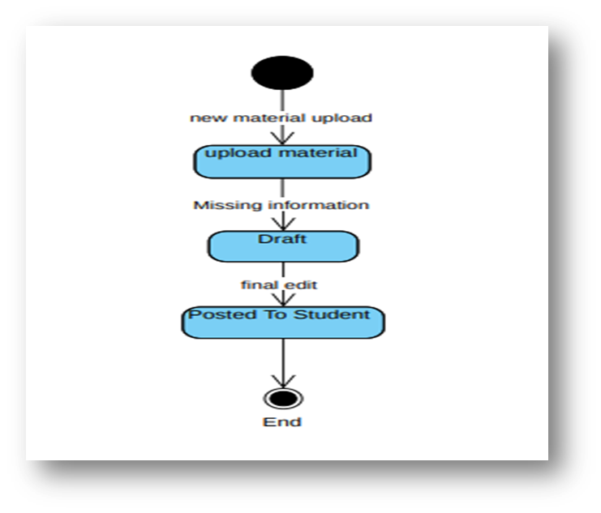

4.2 6(state chart cont(2))

### Activity Diagram

4.2 7(Activity diagram)

4.2 8(Activity diagram cont(1))

4.2 9(Actvity diagram cont(2))

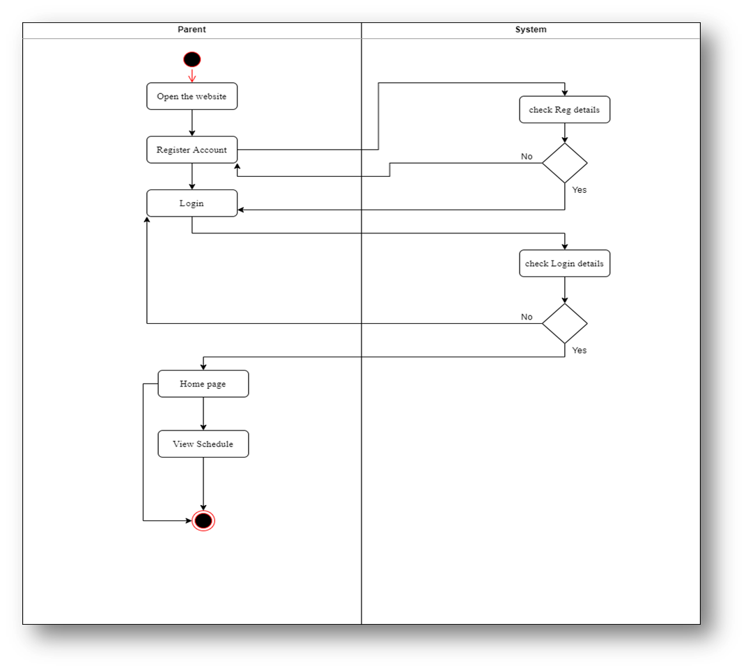

4.2 10 (Activity diagram cont(3))

4.2 11(Activity diagram cont(4))

4.2 12(Activity diagram cont(5))

4.2 13(Activity diagram cont(6))

4.2 14(Activity Diagram cont(7))

4.2 15(Activity Diagram cont(8))

4.2 16(Activity diagram cont(9))

4.2 17(Activity diagram cont(10))

4.2 18(Activity Diagram cont(11))

4.2 19(Activity Diagram cont(12))

4.2 20(Activity Diagram cont(13))

4.2 21(Activity Diagram cont(14))

4.2 22(Activity Diagram cont(15))

4.2 23(Activity diagram Cont(16))

4.2 24(Activity Diagram Cont(17))

4.2 25(Activity Diagram cont(18))

### Sequence Diagram

4.2 26(Sequence Diagram)

4.2 27(Sequence Diagram cont(1))

4.2 28(Sequence Diagram cont(2))

4.2 29(Sequence Diagram cont(3))

4.2 30(sequence Diagram cont(4))

4.2 31(Sequence diagram cont(5))

4.2 32(Sequence Diagram cont(6))

4.2 33(Sequence Diagram cont(7))

4.2 34(Sequence Diagram cont(8))

4.2 35(Sequence diagram cont(9))

'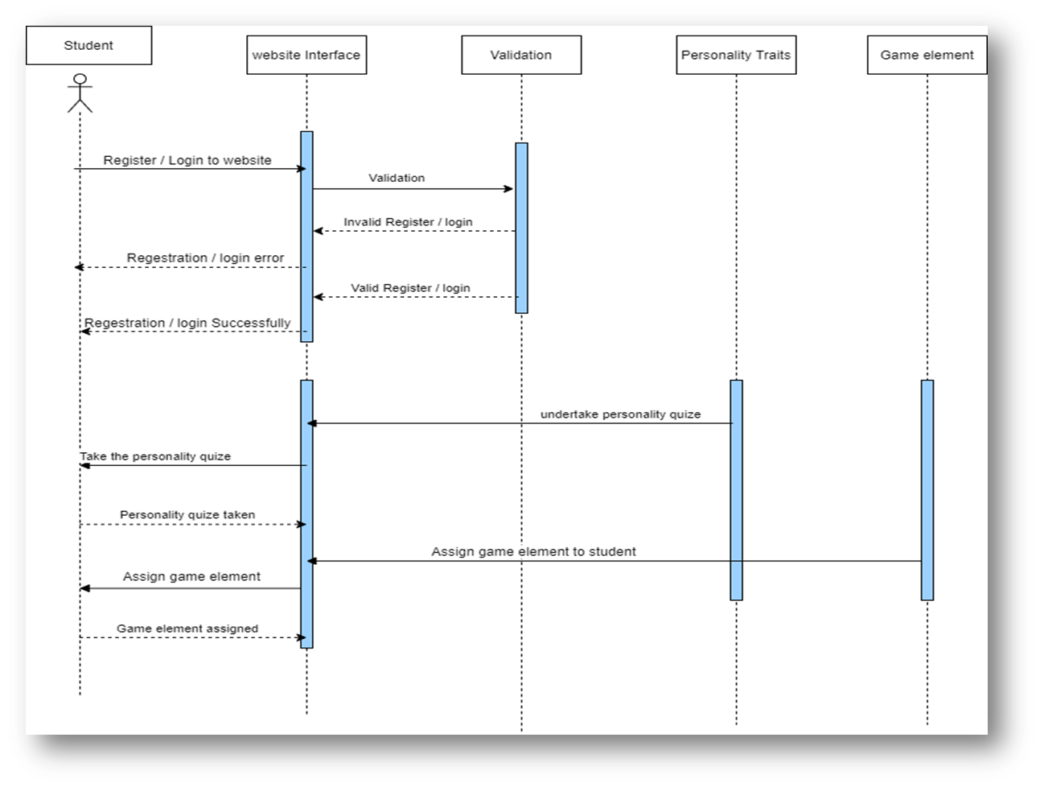

4.2 36(Sequence Diagram cont(10))

4.2 37(Sequence Diagram cont(11))

4.2 38(Squence Diagram cont(12))

Chapter Five

# Product Implementation

Chapter Six

# FUTURE WORK AND CONCLUSION

## Future work:

Recently we think a lot about the future of education and learning. Topics we are extremely passionate about. We are more convinced than ever that we´re on the brink of experiencing a massive and super exciting educational sea change. the teachers still mostly talks, and the students mostly listens. There will be no differences between learning in person and learning online. The communications architecture is still one-to-many. There will be no class scale. We want to lead this field among our competitors. We always keep in touch with what is new and useful to society in this field.

## Conclusion

E-learning is not just a change of technology. It is part of a redefinition of how we as a species transmit knowledge, skills, and values to students. Online Education has brought a positive impact in the lives of students, teachers, and parents. It has given an opportunity to take up additional courses along with their studies as per their convenience. Online education has also helped the faculty in the institutions to ask students to study some part of syllabus online which do not require much of classroom instructions. So, the online study helps the faculty to save time in which they can interact with the students more. The quality of education has improved by online courses and even it has become easy for students to refer the content as per their leisure. education increase even more and will be beneficial for students, professionals and also institutions.

**6.3 References**

1. <https://www.classcraft.com/>
2. <https://new.edmodo.com/>
3. <https://www.weareteachers.com/>
4. <https://www.e-learningforkids.org/>
5. <https://www.pbslearningmedia.org/>